RDC to JJMS ASN.

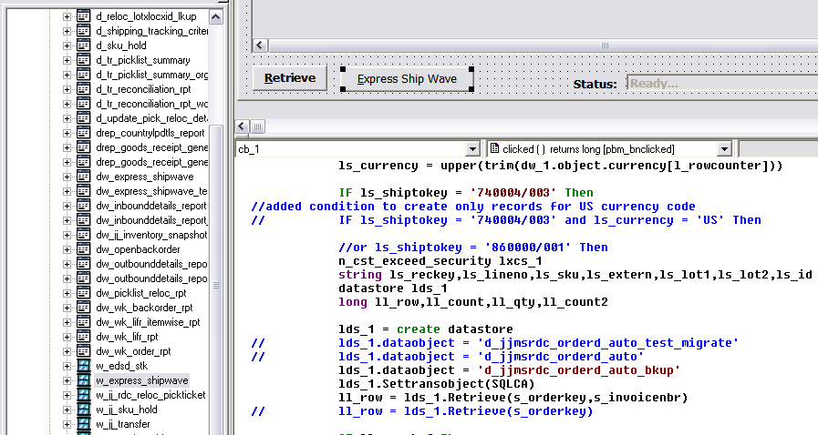

Allow ops to select drow drop by FF ()

